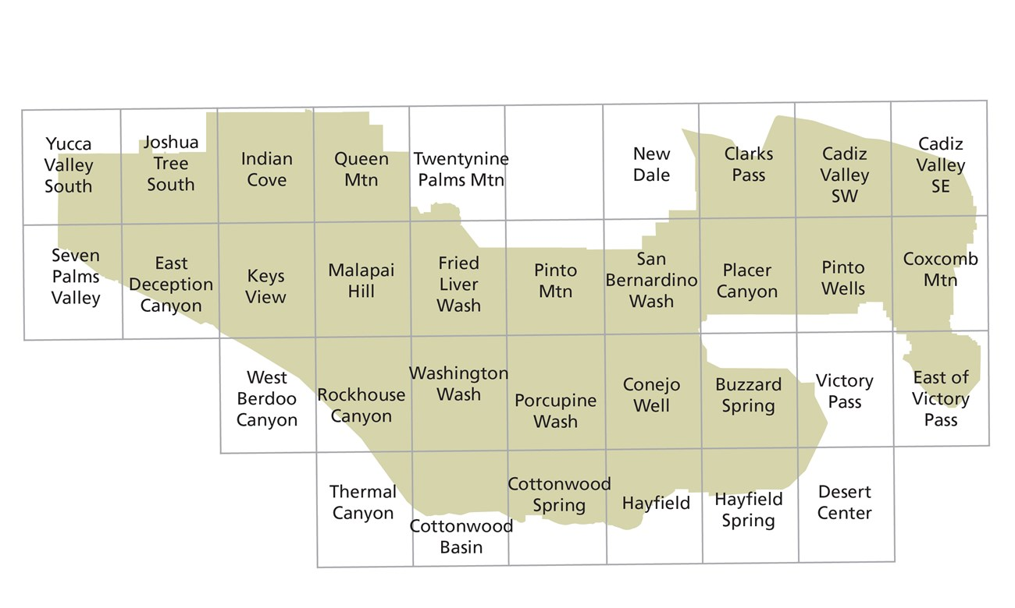

|  |  |  |
| --- | --- | --- |
| [Yucca Valley South](https://store.usgs.gov/product/469078) | [Joshua Tree South](https://store.usgs.gov/product/512163) | [Indian Cove](https://store.usgs.gov/product/493568) |
| [Queen Mountain](https://store.usgs.gov/product/464031) | [Twentynine Palms Mountain](https://store.usgs.gov/product/484719) | [New Dale](https://store.usgs.gov/product/487914) |
| [Clarks Pass](https://store.usgs.gov/product/486359) | [Cadiz Valley SW](https://store.usgs.gov/product/506194) | [Cadiz Valley SE](https://store.usgs.gov/product/501165) |
| [Palms Valley](https://store.usgs.gov/product/470377) | [East Deception Canyon](https://store.usgs.gov/product/465577) | [Keys View](https://store.usgs.gov/product/483816) |
| [Malapai Hill](https://store.usgs.gov/product/478874) | [Fried Liver Wash](https://store.usgs.gov/product/492063) | [Pinto Mountain](https://store.usgs.gov/product/468573) |
| [San Bernardino Wash](https://store.usgs.gov/product/516405) | [Placer Canyon](https://store.usgs.gov/product/499848) | [Pinto Wells](https://store.usgs.gov/product/483282) |
| [Coxcomb Mountains](https://store.usgs.gov/product/491668) | [West Berdoo Canyon](https://store.usgs.gov/product/481899) | [Rockhouse Canyon](https://store.usgs.gov/product/480460) |
| [Washington Wash](https://store.usgs.gov/product/472918) | [Porcupine Wash](https://store.usgs.gov/product/473988) | [Conejo Well](https://store.usgs.gov/product/468528) |
| [Buzzard Spring](https://store.usgs.gov/product/497210) | [Victory Pass](https://store.usgs.gov/product/47096) | [East of Victory Pass](https://store.usgs.gov/product/487402) |
| [Thermal Canyon](https://store.usgs.gov/product/505253) | [Cottonwood Basin](https://store.usgs.gov/product/496887) | [Cottonwood Spring](https://store.usgs.gov/product/510840) |
| [Hayfield](https://store.usgs.gov/product/490481) | [Hayfield Spring](https://store.usgs.gov/product/503124) | [Desert Center](https://store.usgs.gov/product/516398) |